UNION & AGGREGATOR

M_AGG_UNION_AMOUNTS

CREATE TABLE UNION_AMOUNTS(

AMOUNTID NUMBER(10) PRIMARY KEY,

AMOUNT NUMBER(20,2),

DEPTID NUMBER(2));

INSERT INTO UNION_AMOUNTS VALUES(1, 11111,2);

INSERT INTO UNION_AMOUNTS VALUES(2, 2222,3);

INSERT INTO UNION_AMOUNTS VALUES(3, 2222,3);

INSERT INTO UNION_AMOUNTS VALUES(4, 4444,2);

THEN CREATE A FLAT FILE/CSV WHICH HAS BELOW FIELDS (AMOUNT.DAT)

AMOUNTID,AMOUNT,DEPTID

5,44441,3

6,4332,4

7,4322,2

-- BEFORE COMING TO TARGET TABLE WE WILL FIRST DO THE UNIOn OF FLAT FILE AND TABLE THEN FIND THE AGGREGATOR BASED ON

-- DEPTID

CREATE TABLE T_UNION_AMOUNTS(

DEPTID NUMBER(2),

AMOUNT NUMBER(10));

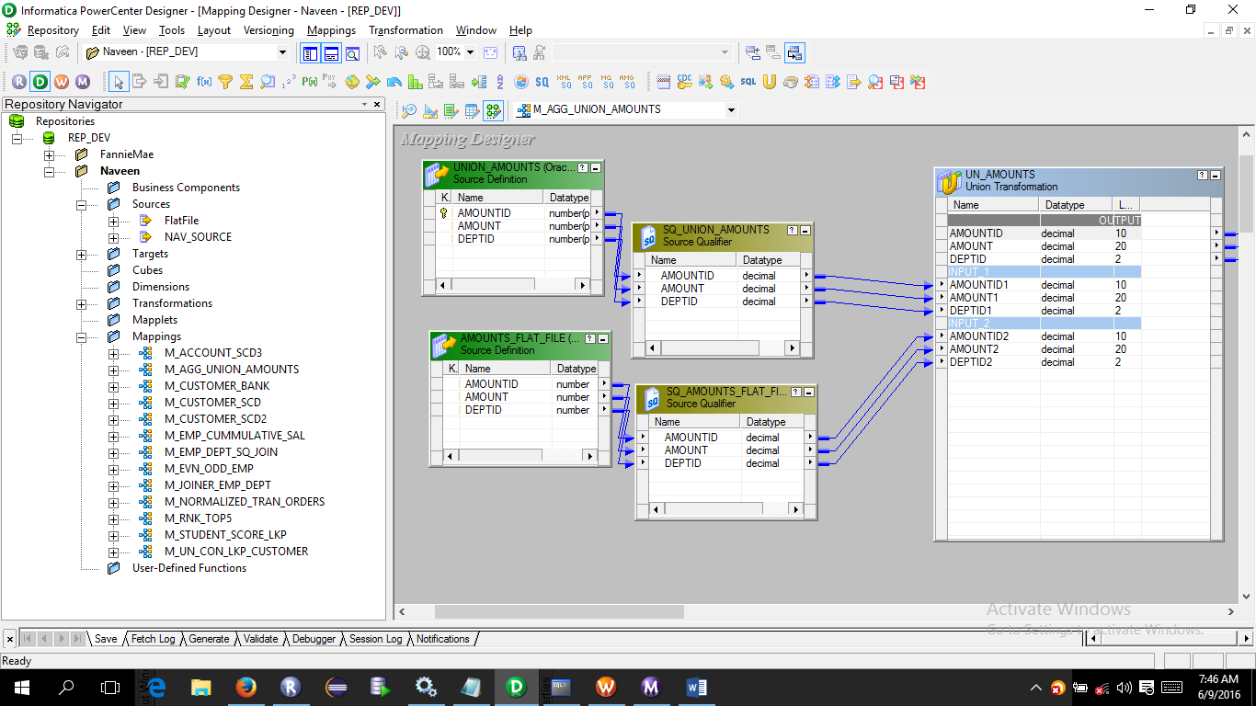

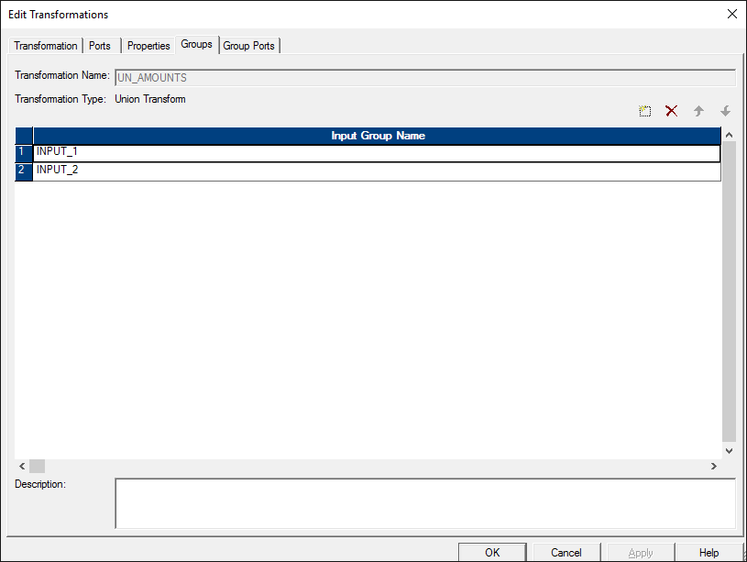

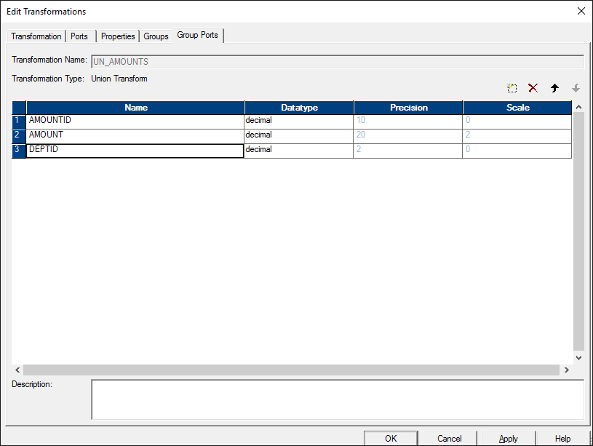

Use aggregator

